**SQL Challenge 1**

**Steve's Car Showroom**

**Introduction**

* Steve runs a top-end car showroom but his data analyst has just quit and left him without his crucial insights.
* So, we have to analyze the data and answer a few questions.

**Tables**

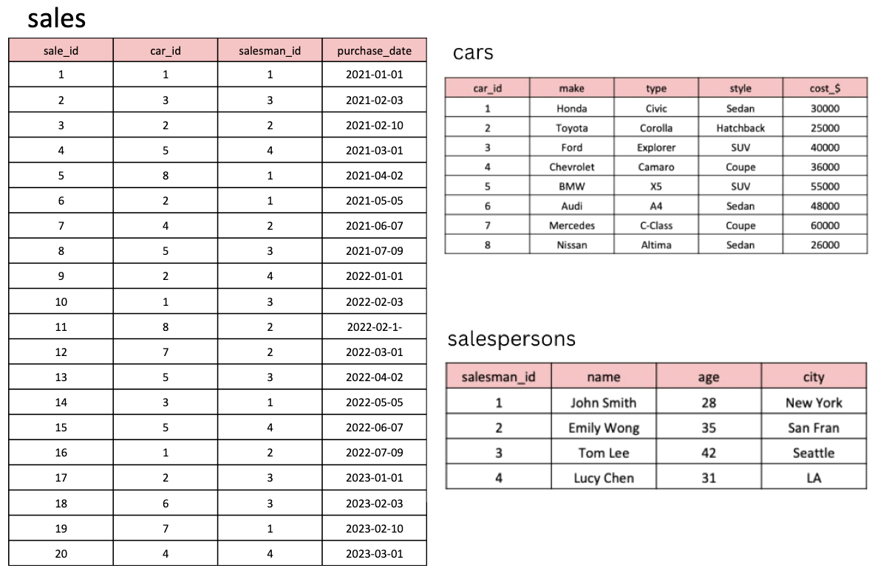

**Questions**

**1. What are the details of all cars purchased in the year 2022?**

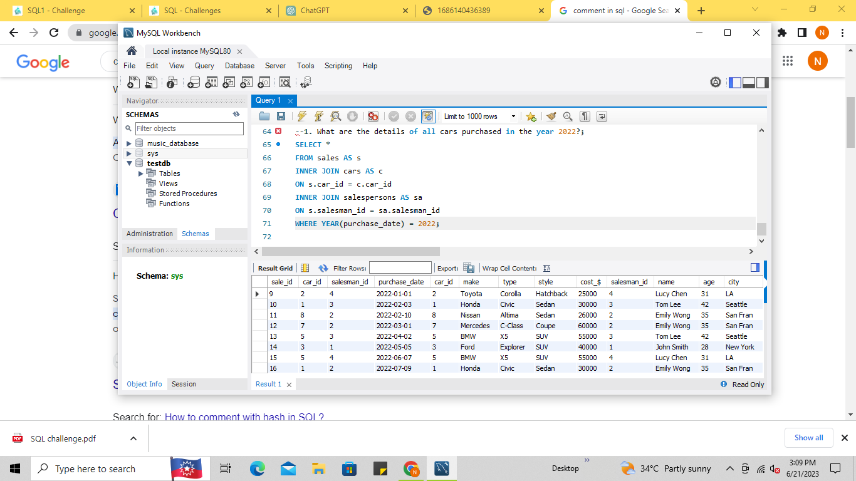

**Output:**



**2. What is the total number of cars sold by each salesperson?**

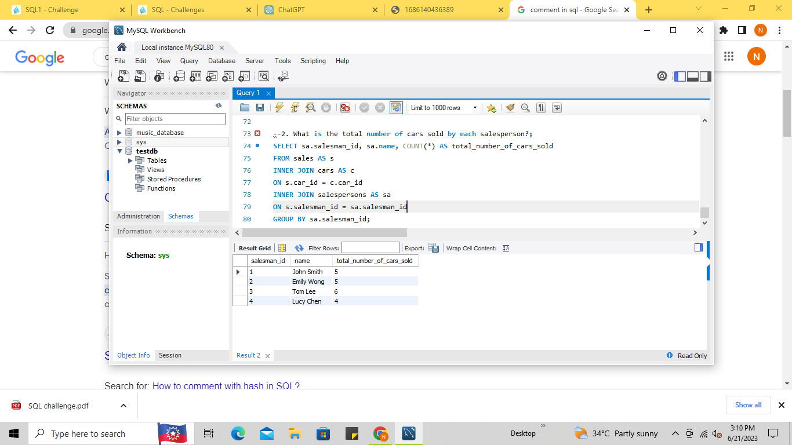

**Output:**



**3. What is the total revenue generated by each salesperson?**

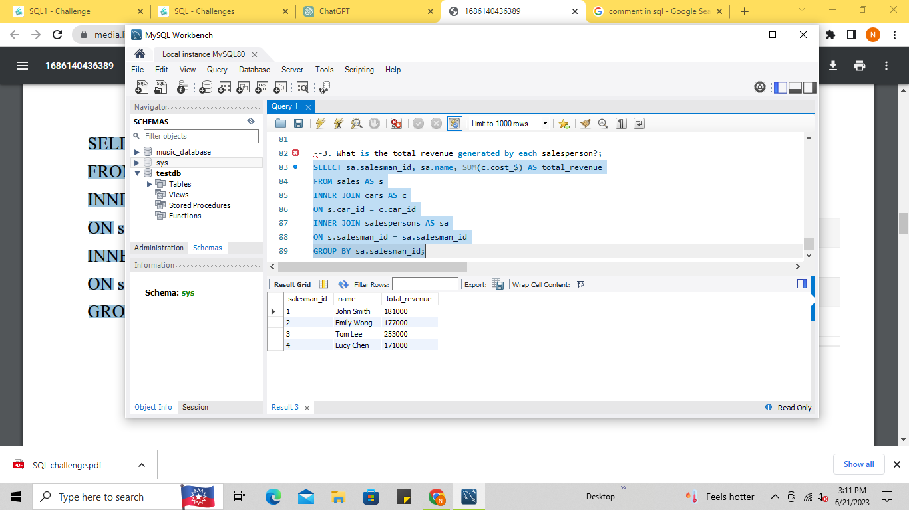

**Output**



**4. What are the details of the cars sold by each salesperson?**

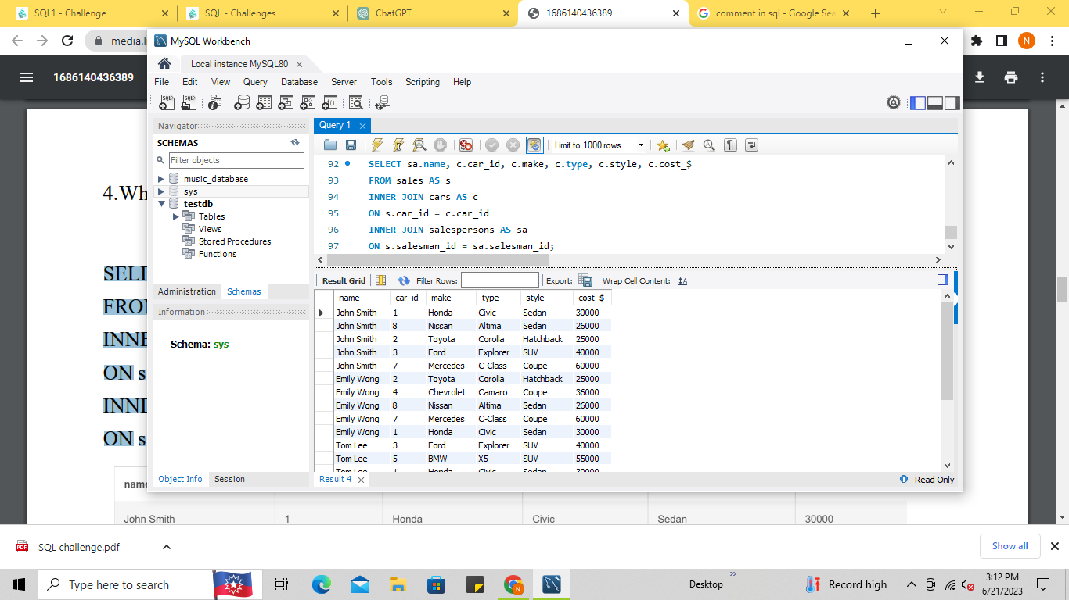

**Output:**

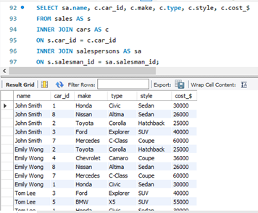

**5. What is the total revenue generated by each car type?**

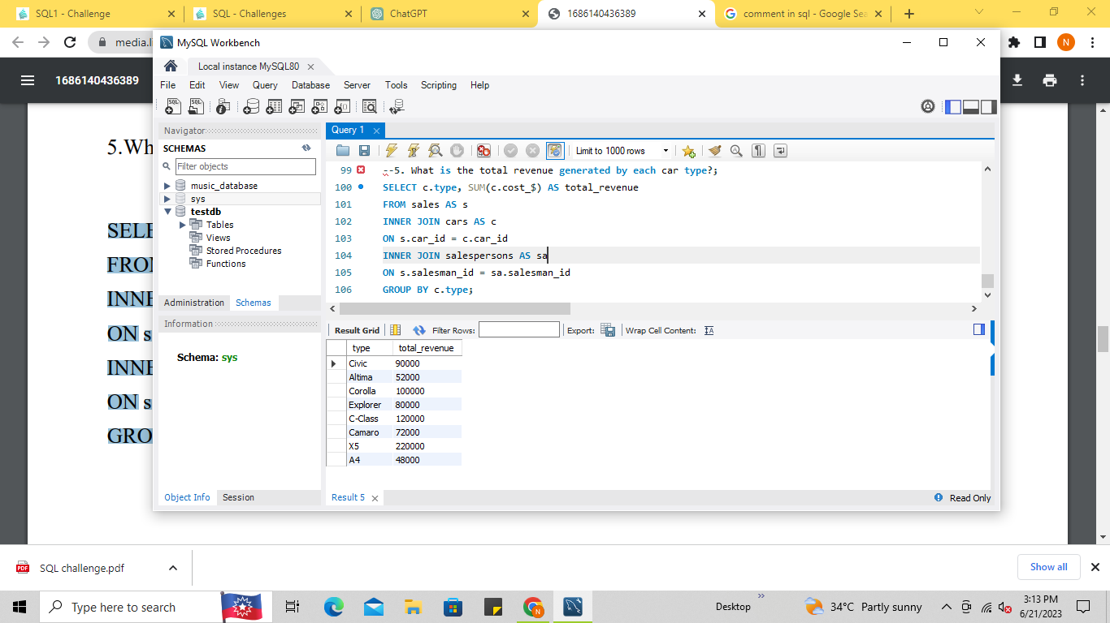

**Output:**

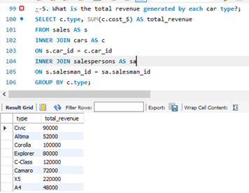

**6. What are the details of the cars sold in the year 2021 by salesperson 'Emily Wong'?**

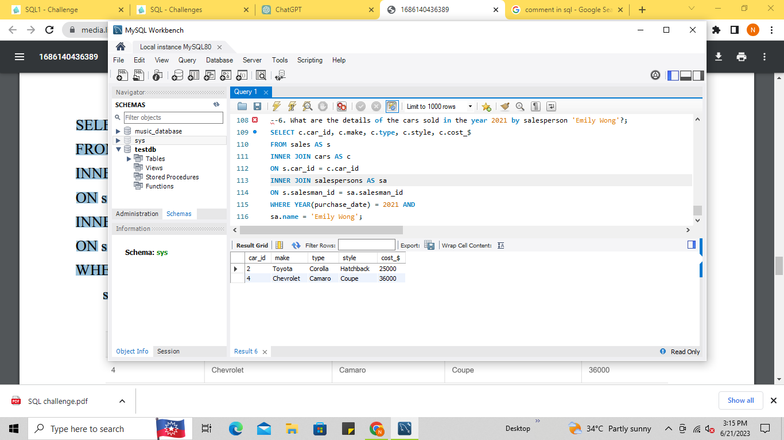

**Output:**



**7. What is the total revenue generated by the sales of hatchback cars?**

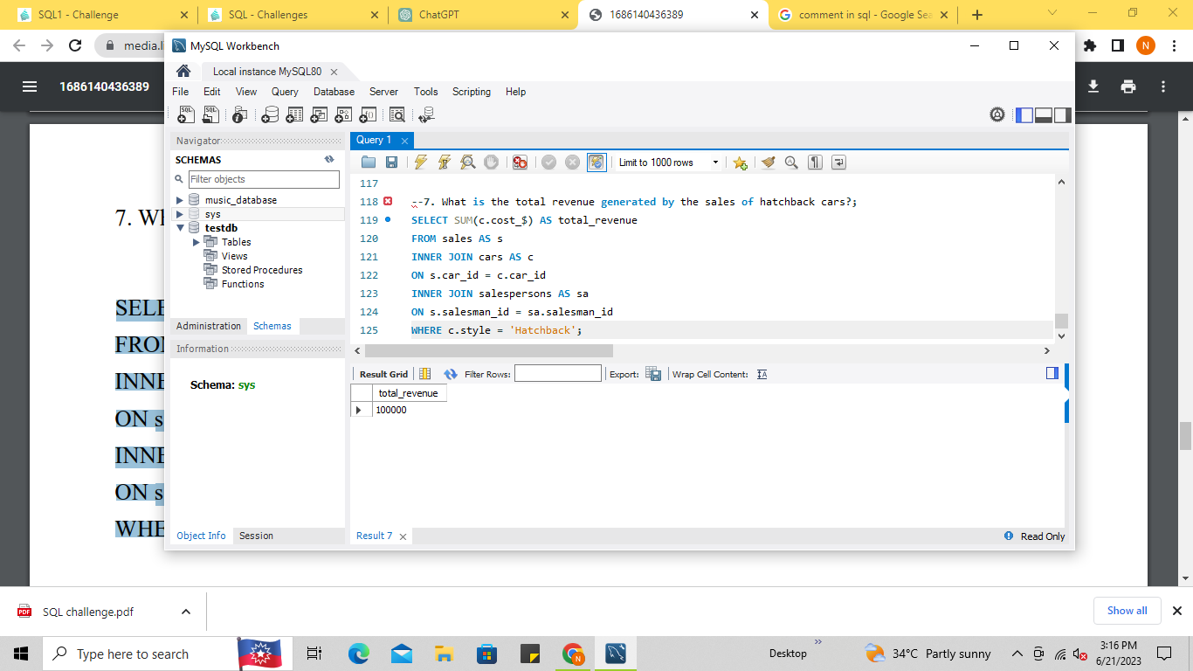

**Output:**



**8. What is the total revenue generated by the sales of SUV cars in the year 2022?**

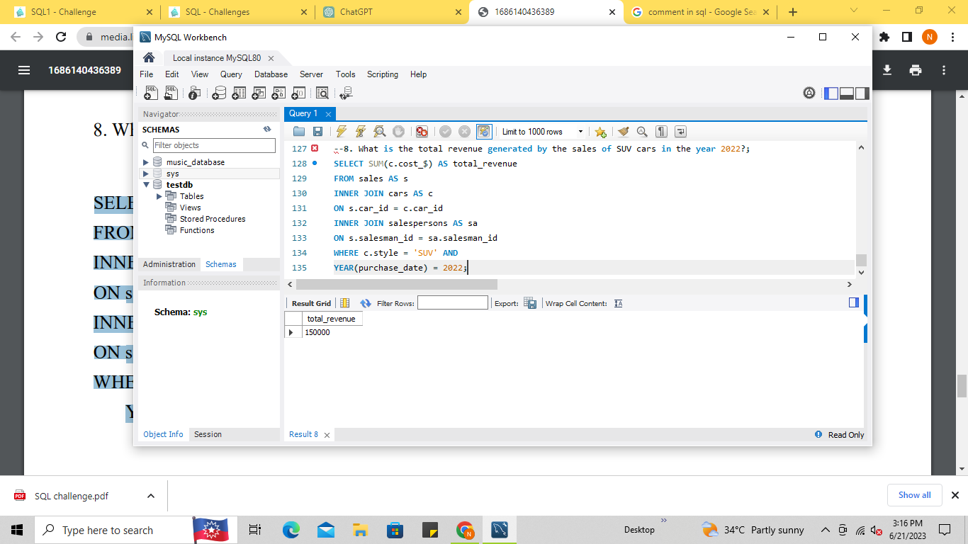

**Output:**



**9. What is the name and city of the salesperson who sold the most number of cars in the year 2023?**

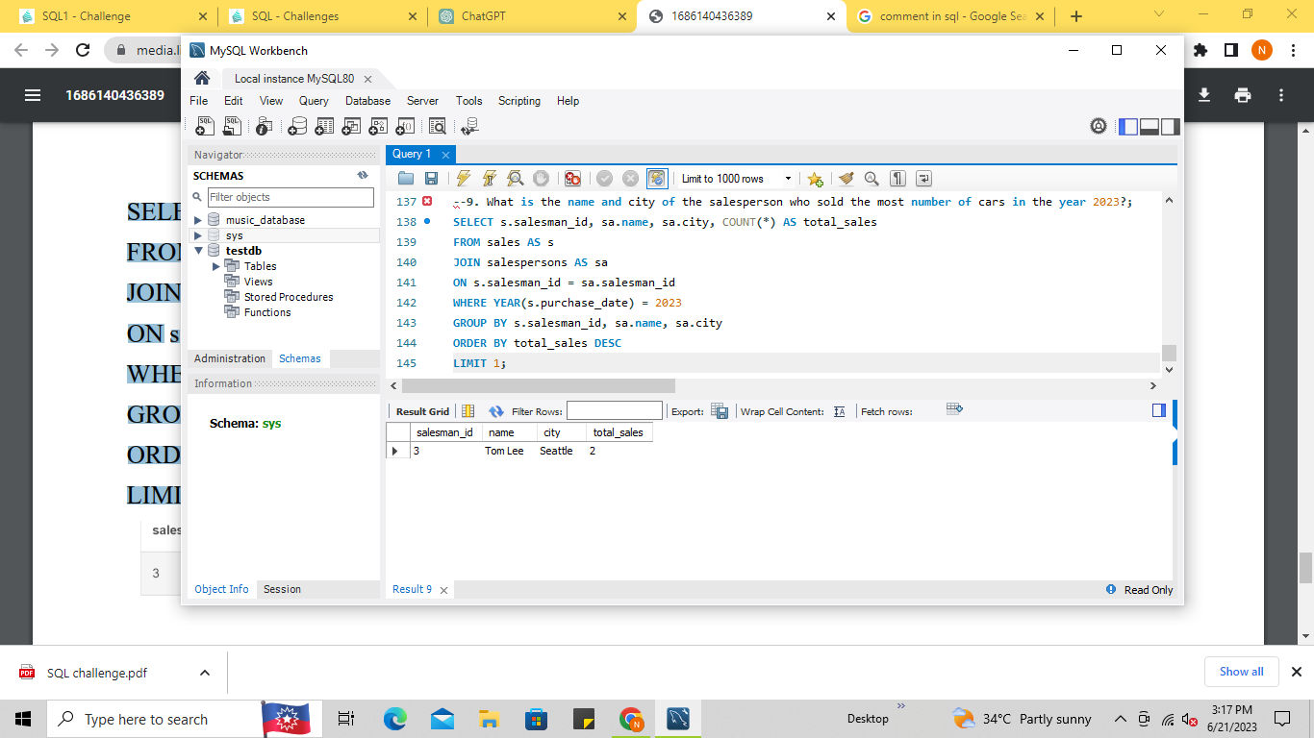

**Output:**



**10. What is the name and age of the salesperson who generated the highest revenue in the year 2022?**

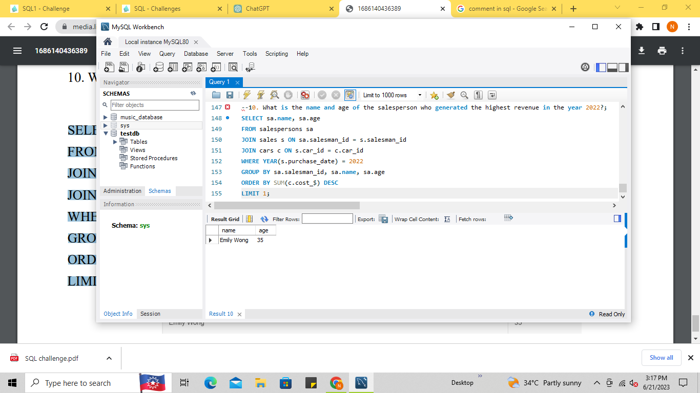

**Output:**

